**JIRA**

**Day 1 - Jira Core + Project Setup**

**Learnt**

1. What Jira is used for in real companies?

2. Jira Software vs Service Management

3. Scrum vs Kanban (when to use what)

**Practical**

1. Created a **Scrum project**

2. Explored:

* Dashboard

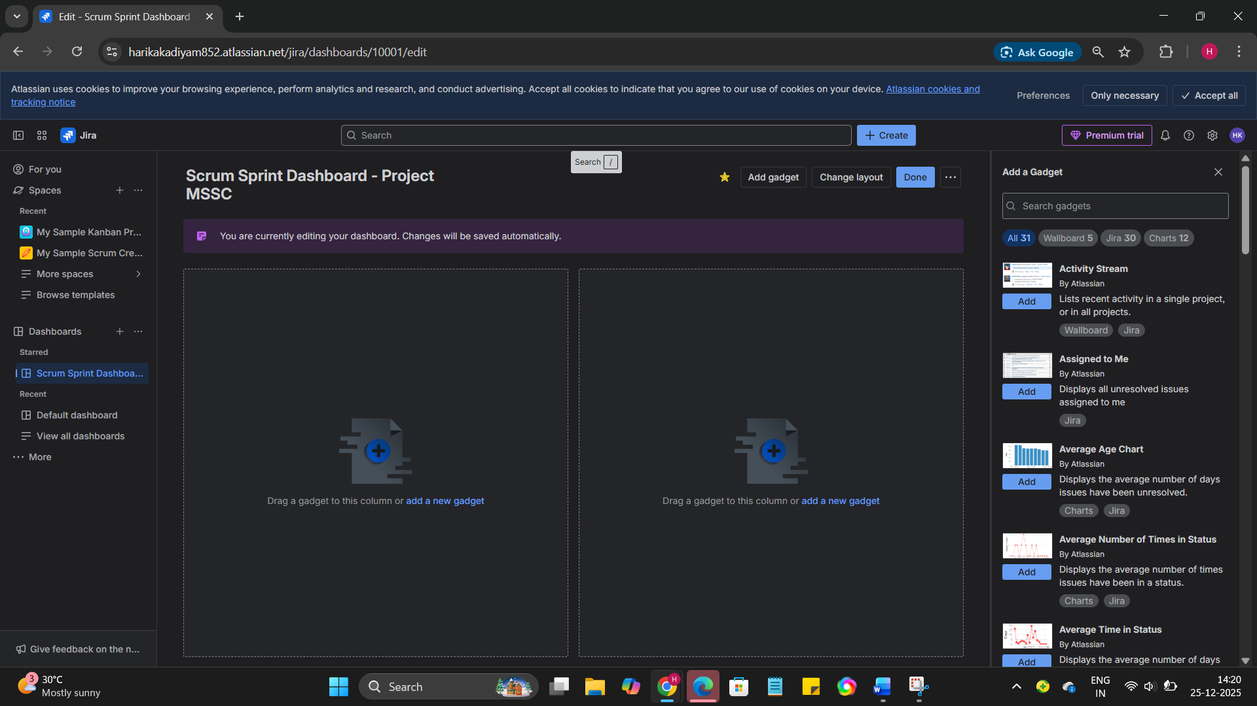

* Backlog

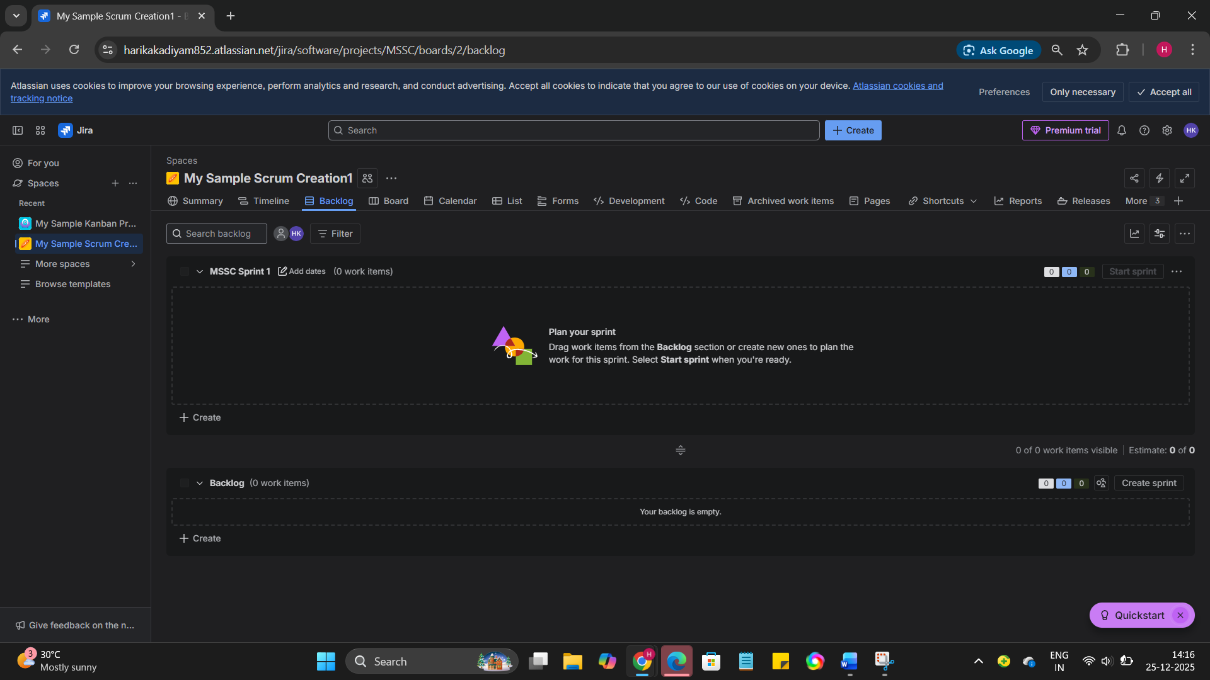

* Board

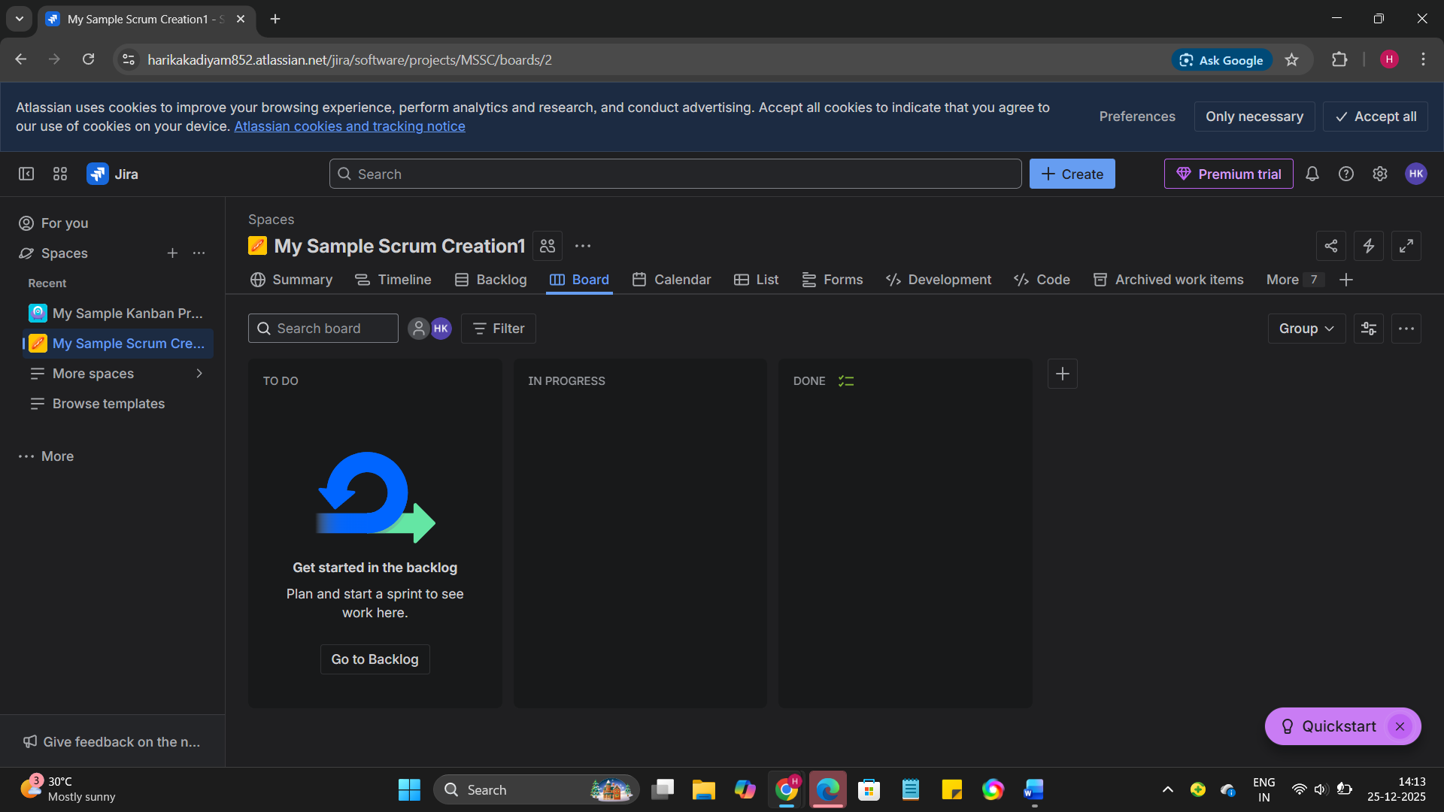

3. Created:

* 1 Epic

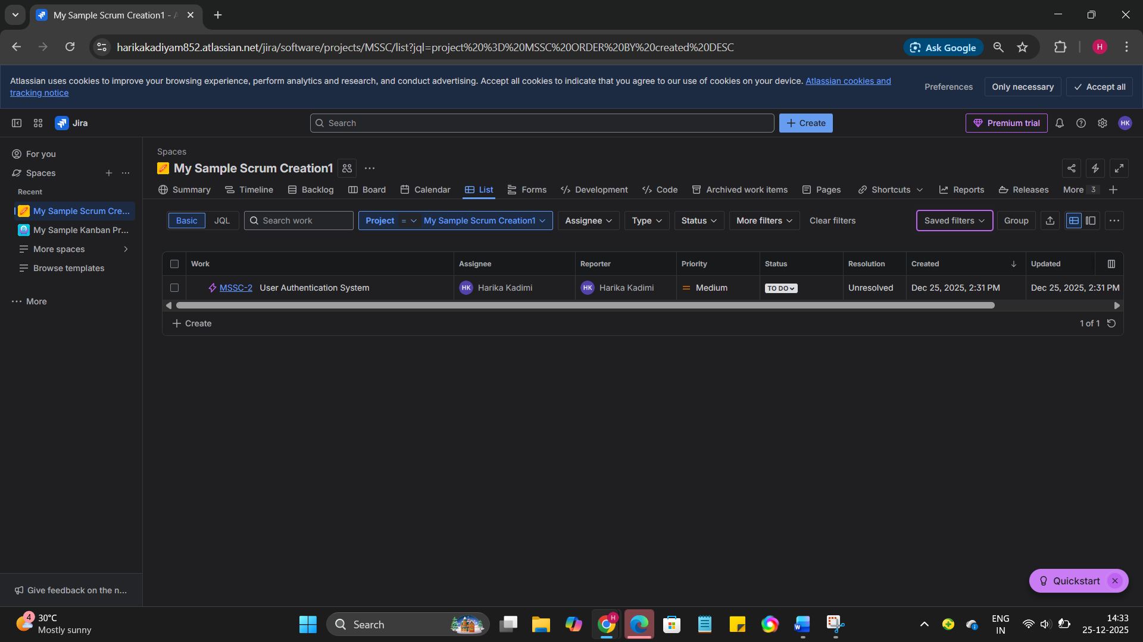

* 3 Stories

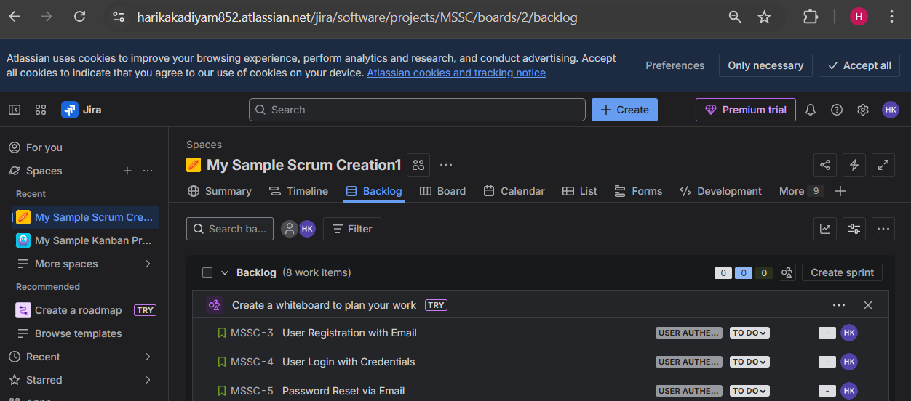

* 5 Tasks

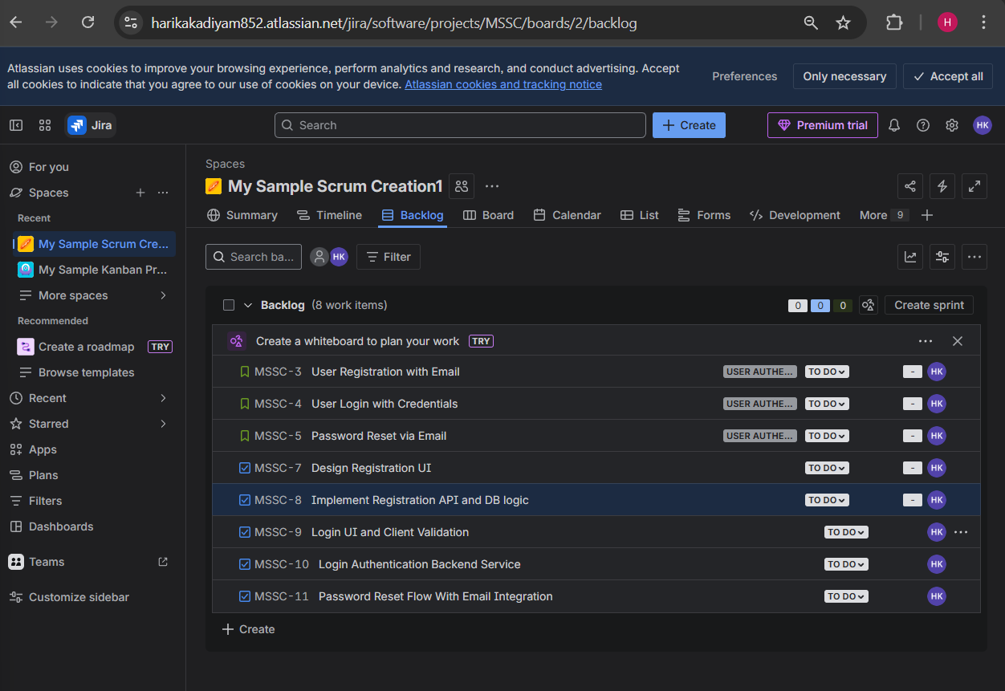

**Day 2 – Issues, Workflow & Daily Usage**

**Learn**

* Issue types: Epic, Story, Task, Bug
* Status flow: To Do → In Progress → Done
* Priority, labels, assignee, description

**Practical**

* Convert 2 tasks into **Bugs**

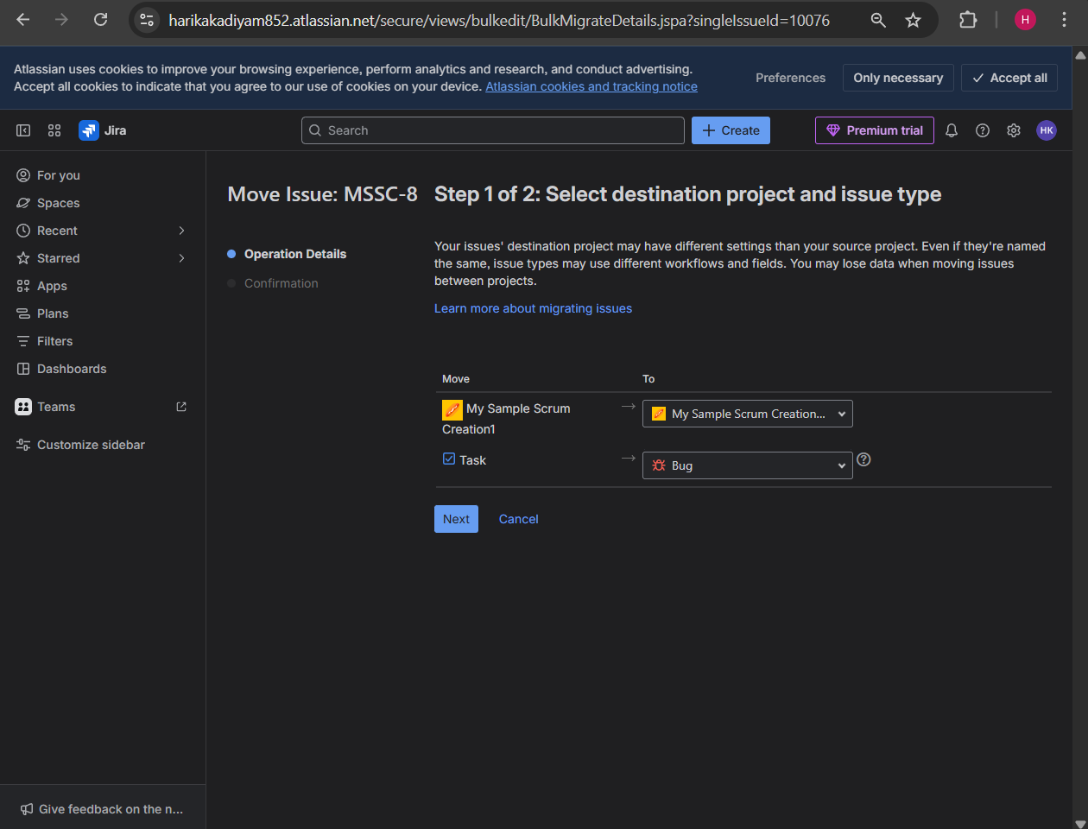

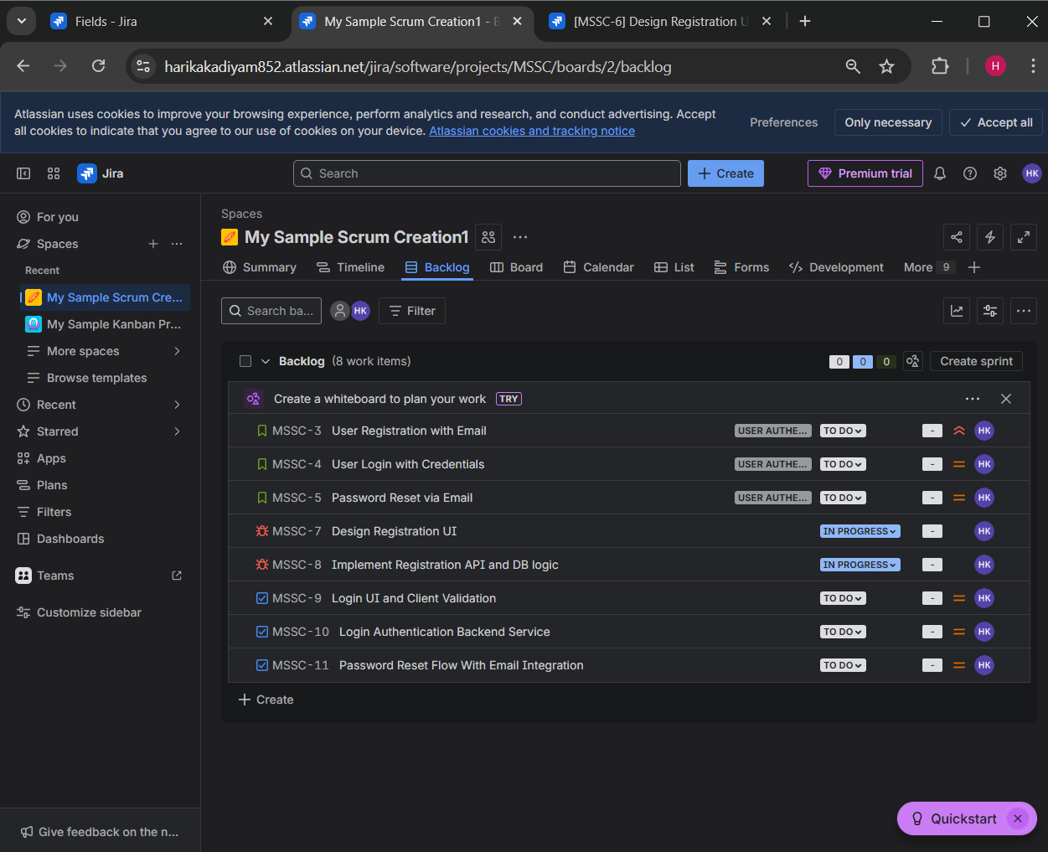

* Move issues across workflow

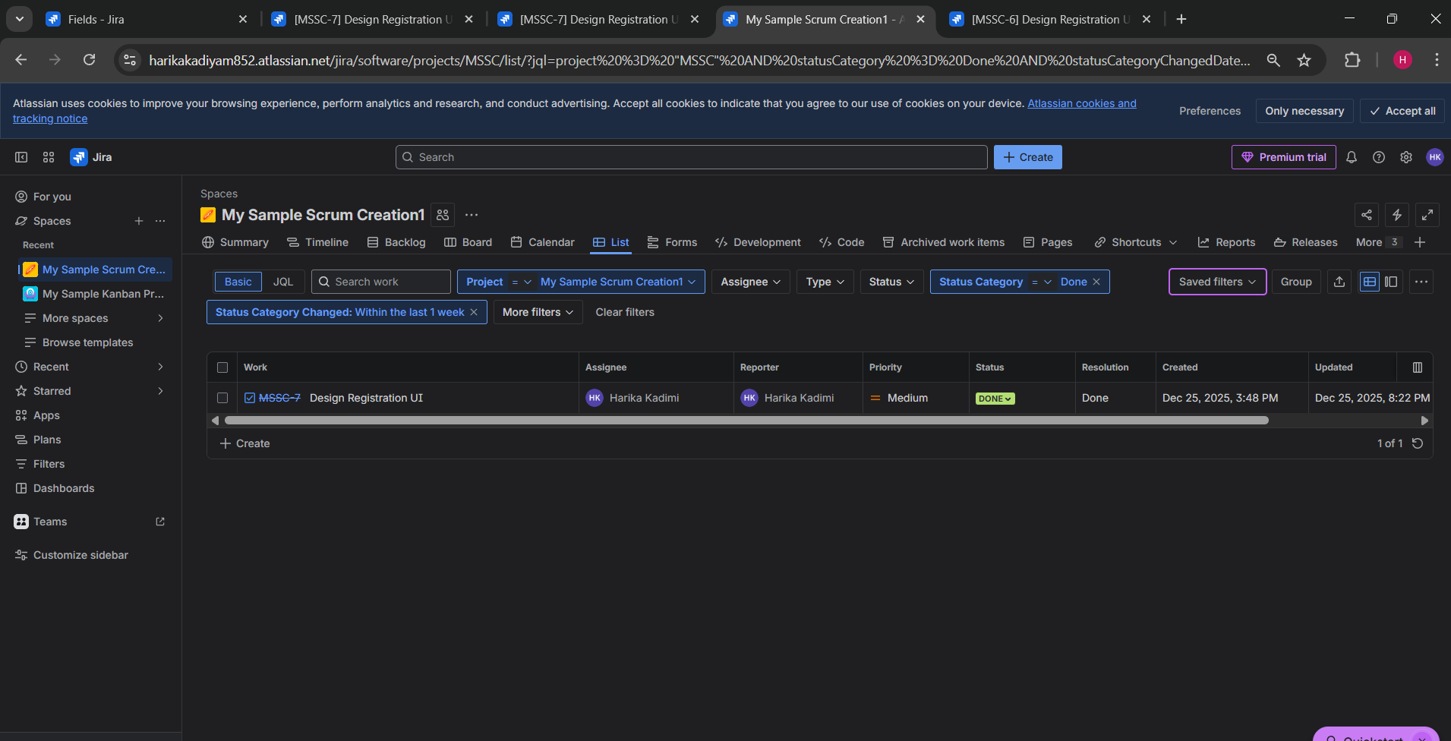

* Link issues (blocks, relates to)

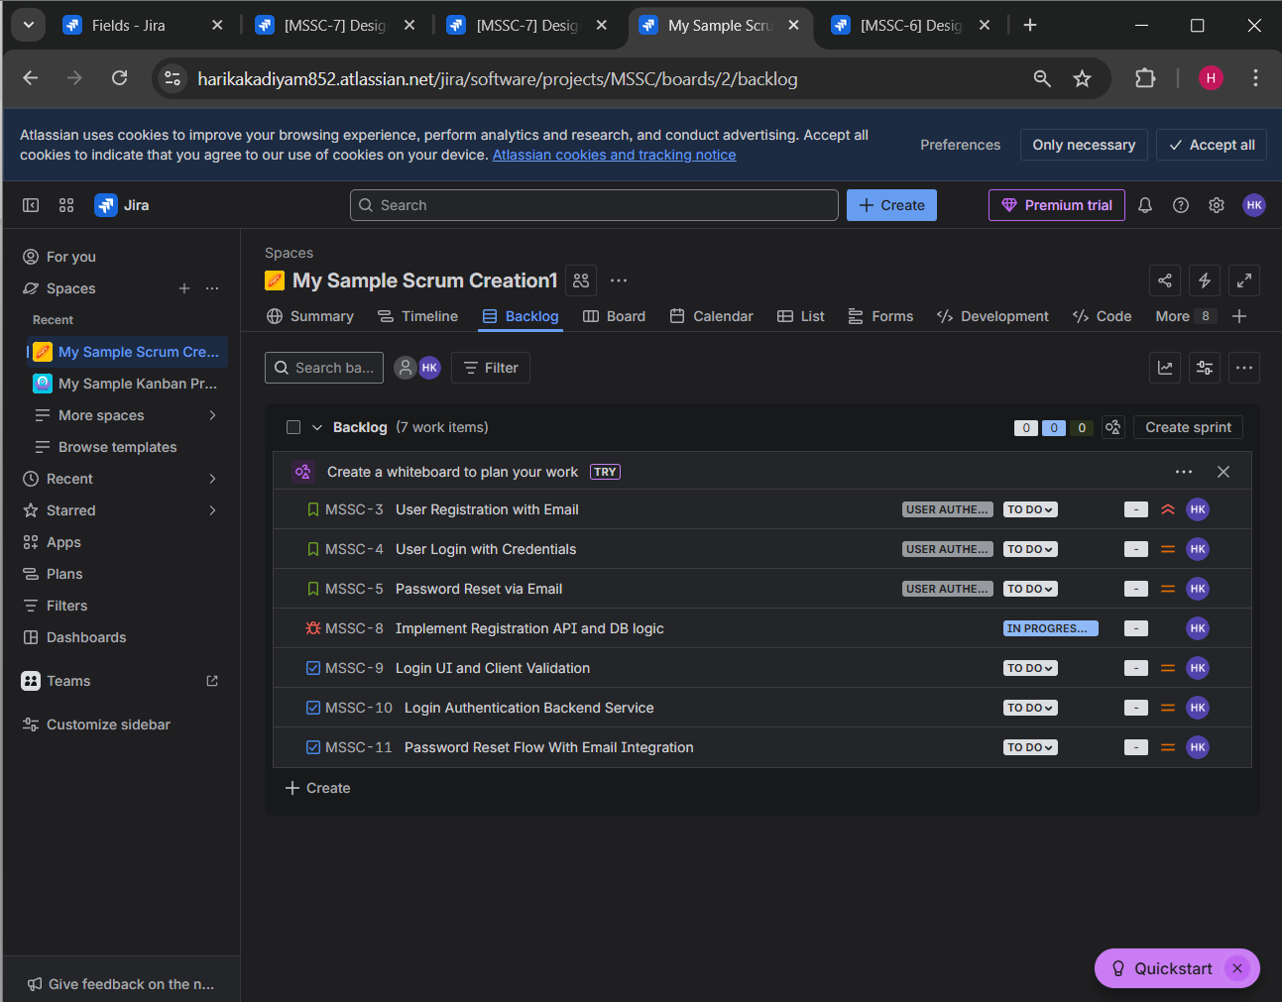

* Add comments and attachments

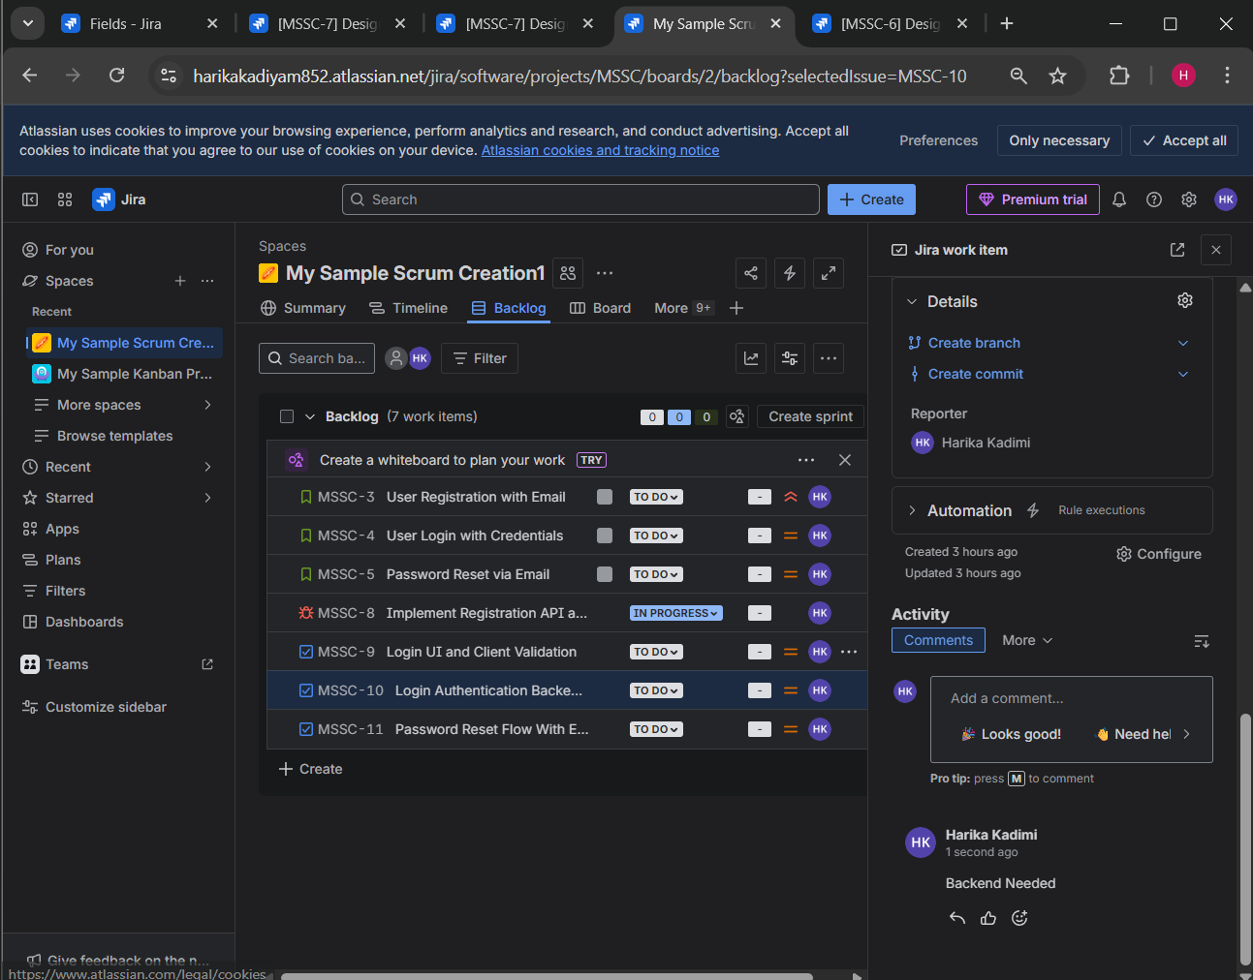

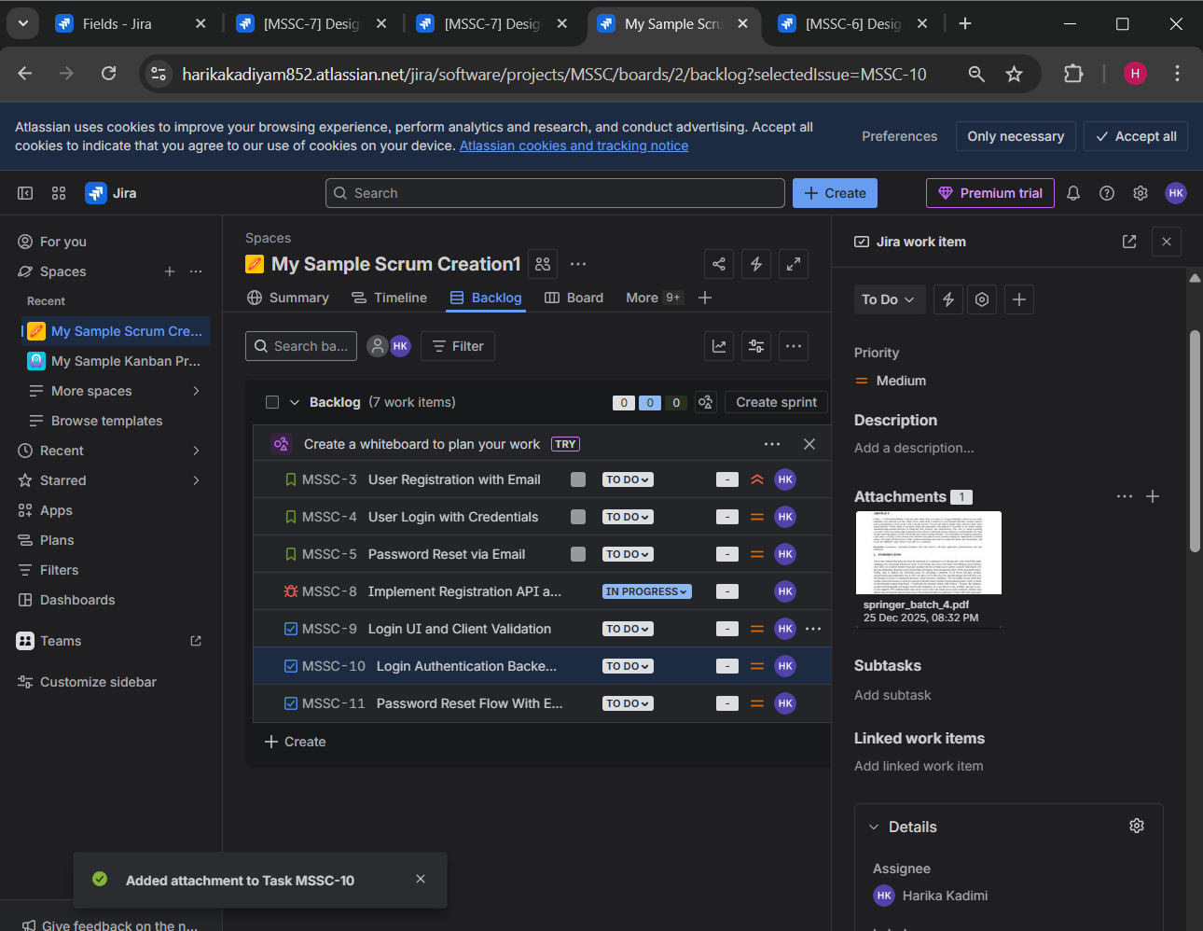

**Day 3 – Scrum Board & Sprint Execution**

**Learn**

* Product backlog vs Sprint backlog
* Sprint planning & execution

**Practical**

* Create a **Sprint**

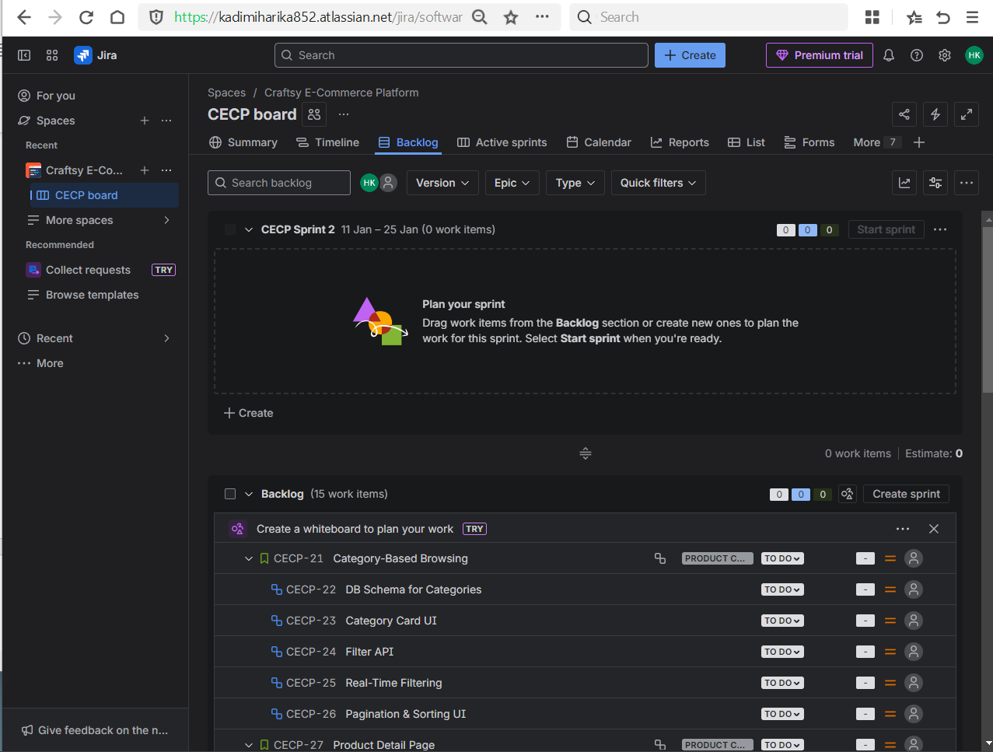

* Add stories to sprint

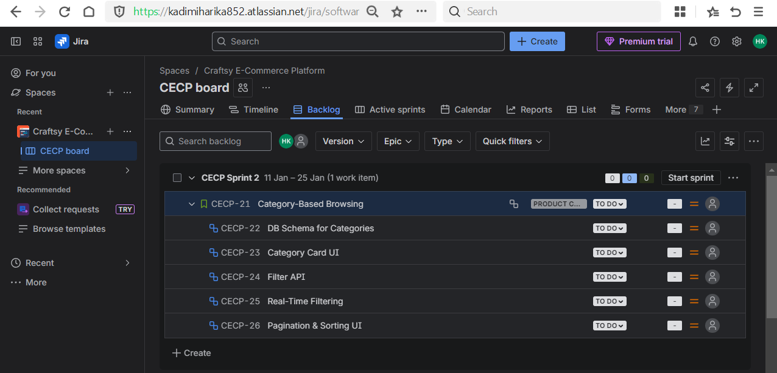

* Start sprint

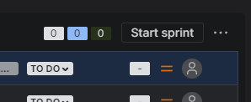

* Move tasks daily

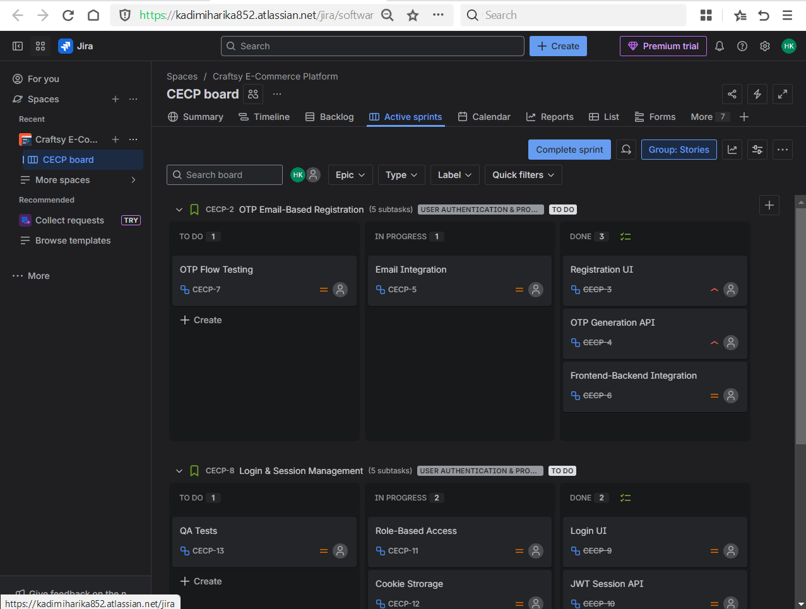

* Complete sprint

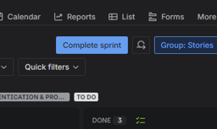

**Day 4 – Kanban + Filters (JQL Basics)**

**Learn**

* Kanban board purpose
* Continuous delivery concept
* JQL fundamentals

**Practical**

* Create a **Kanban project**

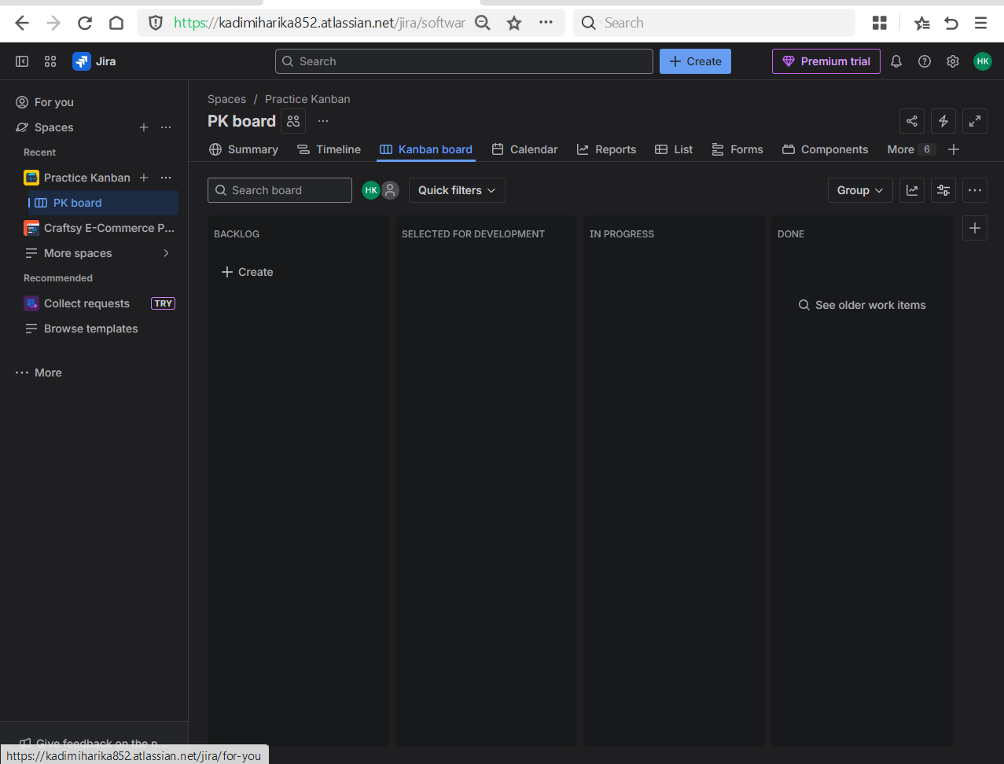

* Create issues and move them

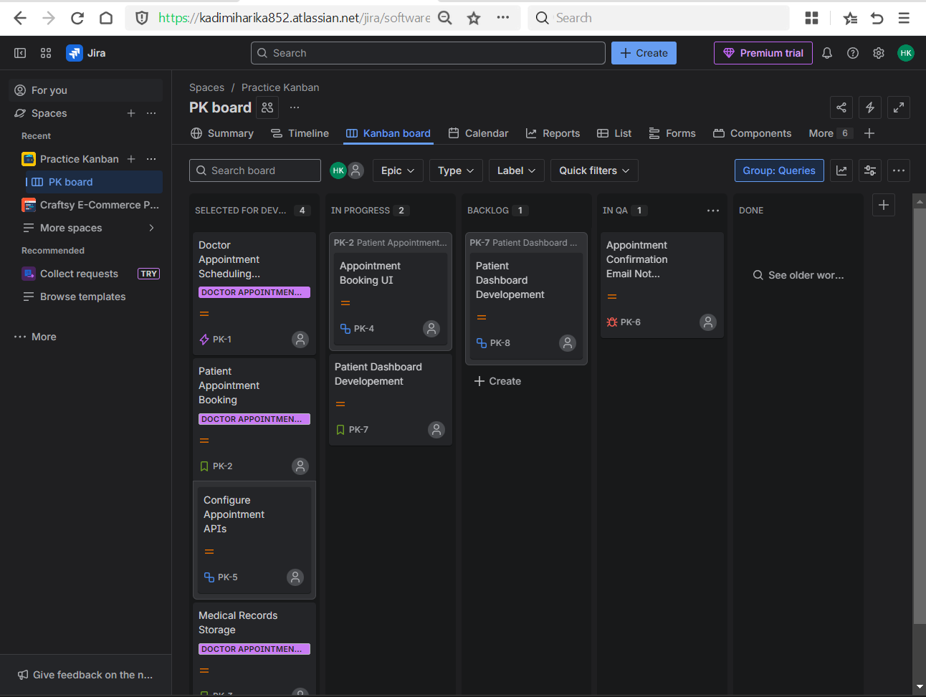

* Use JQL:
  + All issue assigned to you -> assignee = currentUser()

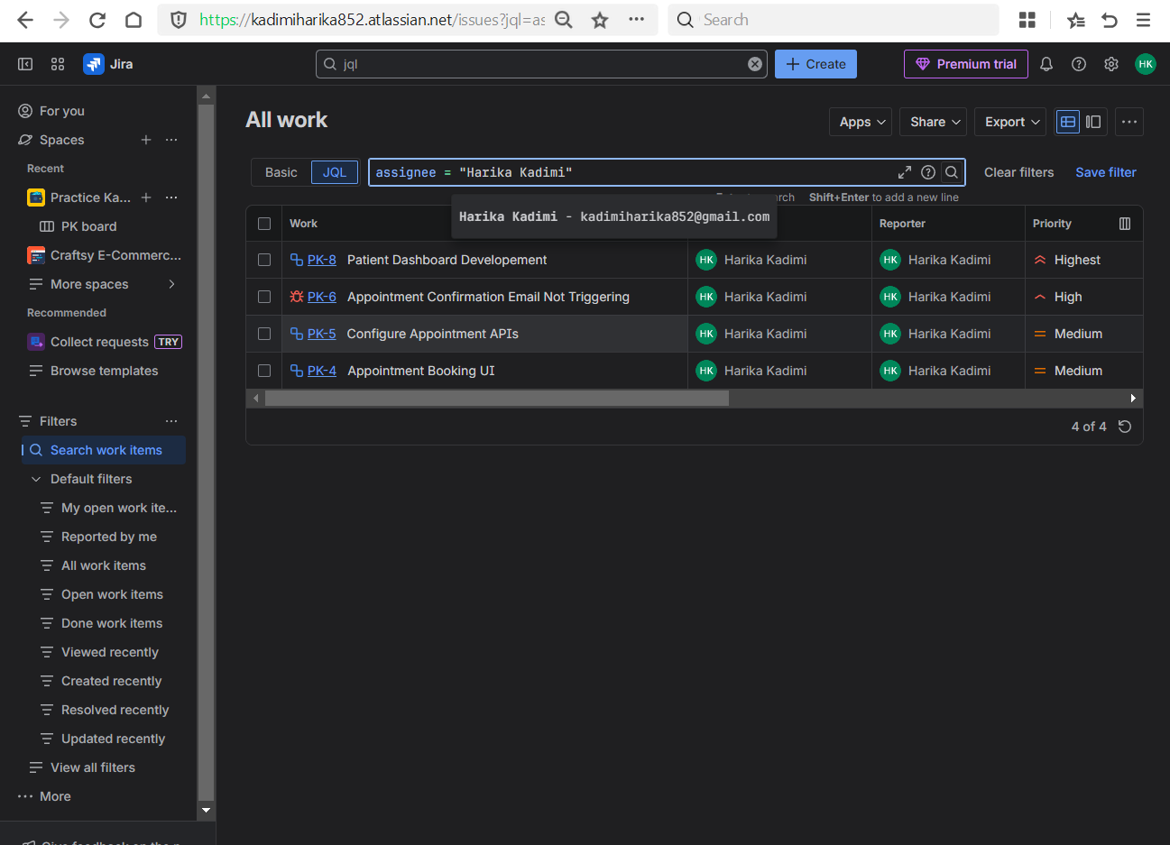

* + Issues not done yet -> status != Done

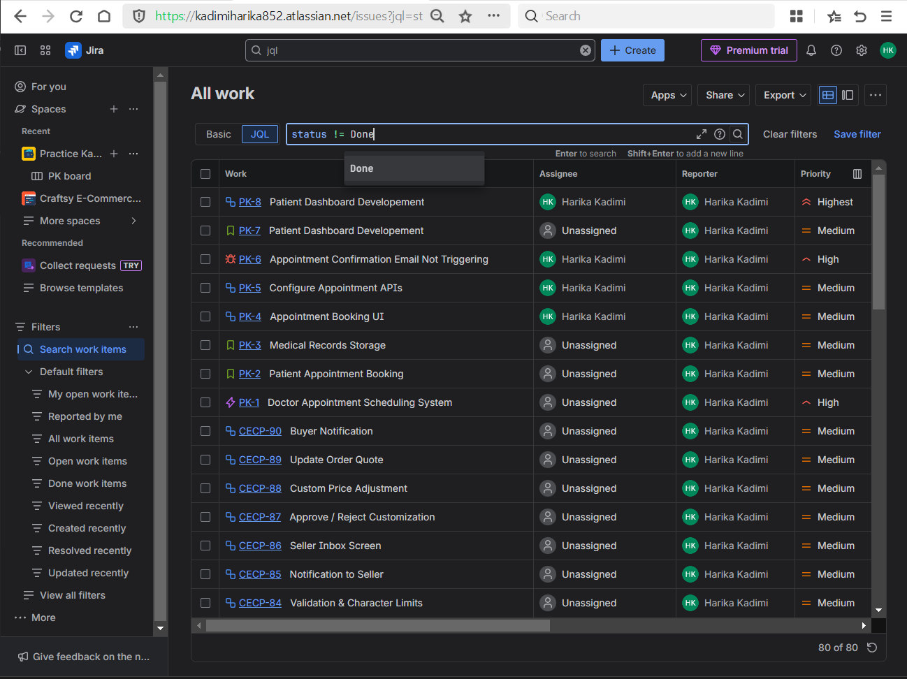

* Specific Space and the issues with only high priority -> Project = “Space Name” AND priority = High

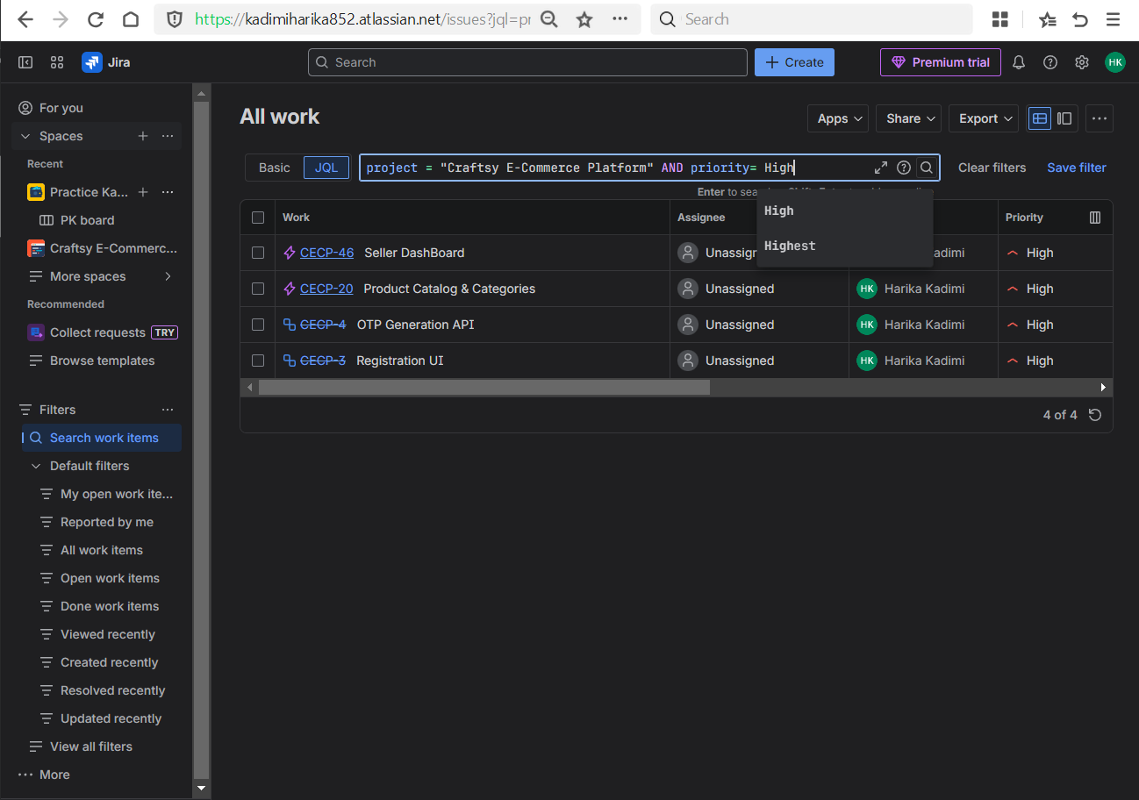

* Tasks due this week -> due <= endofweek()

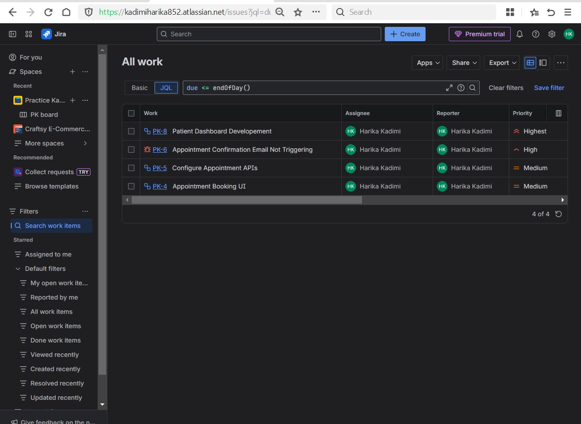

* All “To Do” tasks -> status = “status”

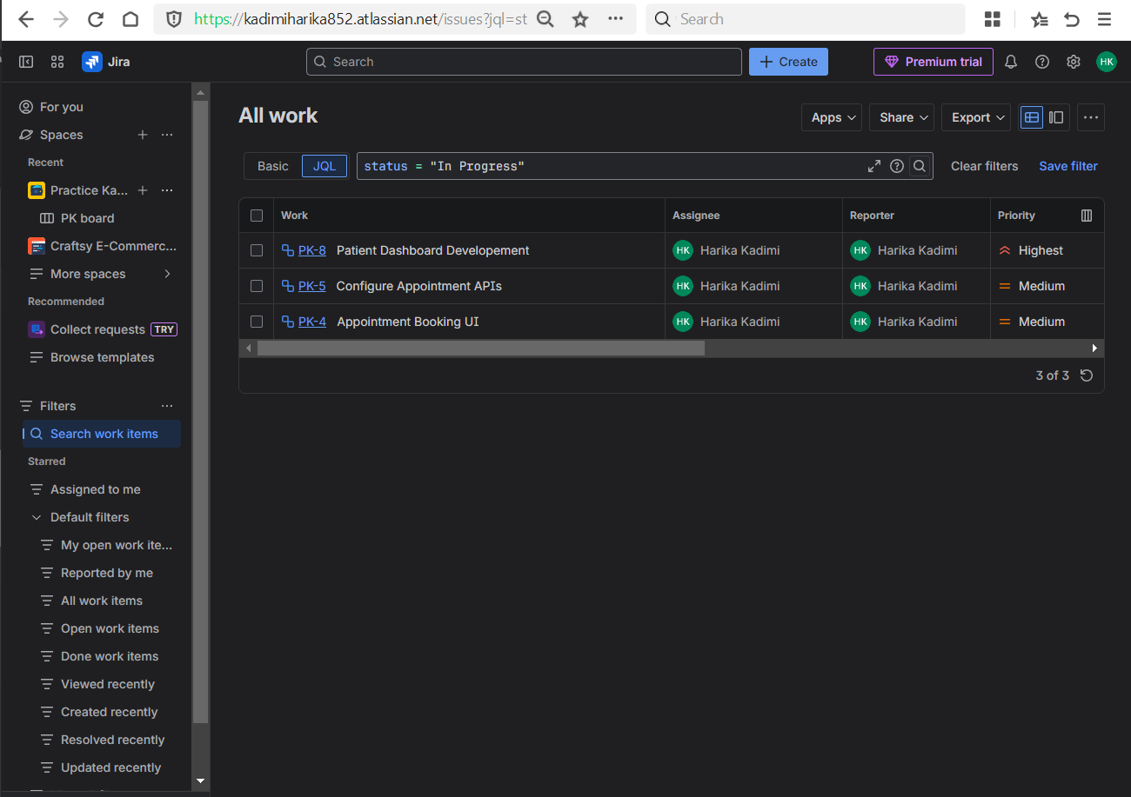

* **Combined Conditions**
* High priority and not done -> priority = priority AND status != Done

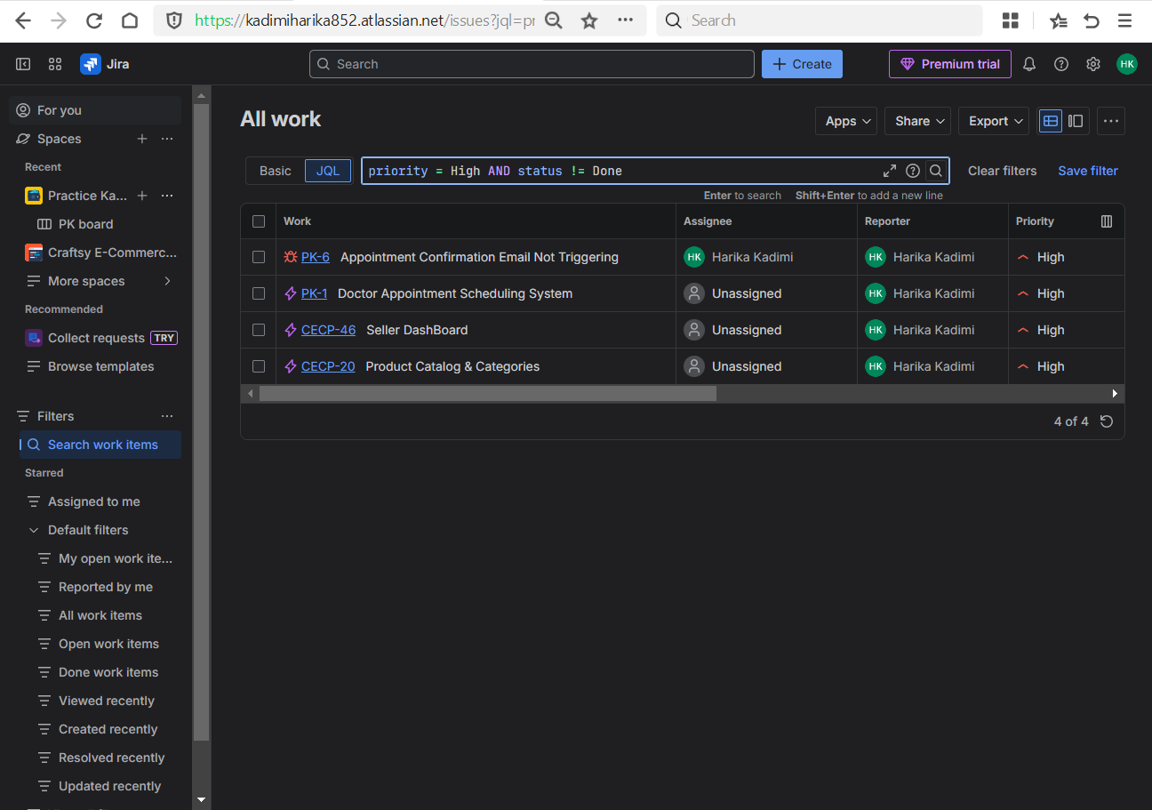

* Assigned to Harika and In Progress -> assignee = Harika AND status = “In Progress”

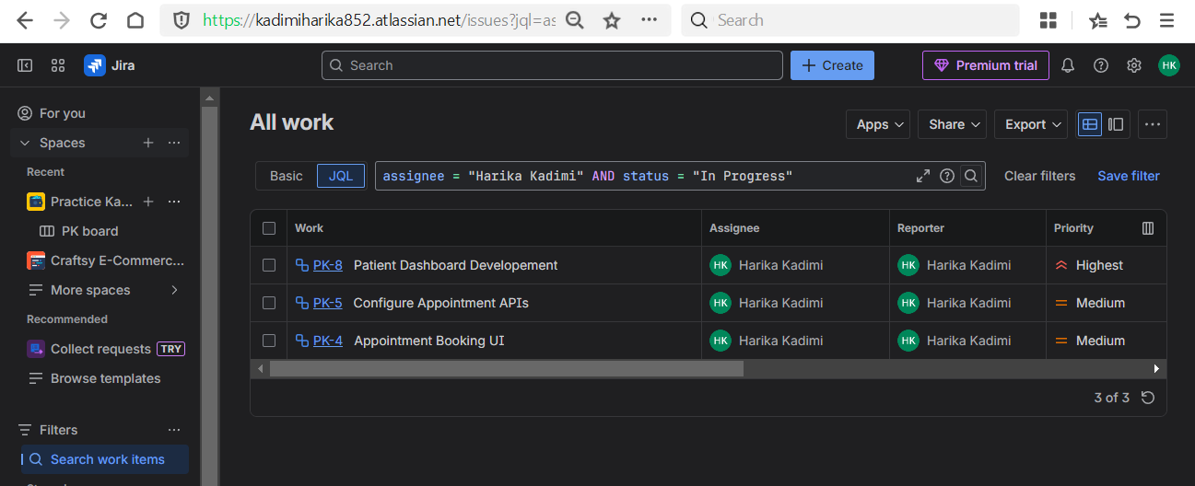

* Issues with labels containing “testing” -> labels IN (testing)

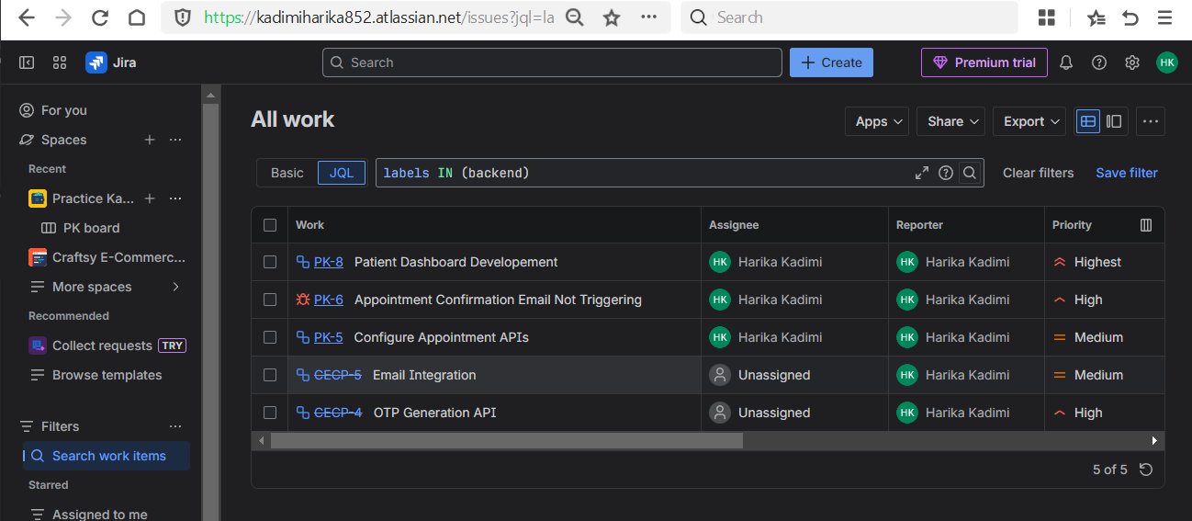

* Summary contains “Keyword” -> summary ~ “keyword to search”

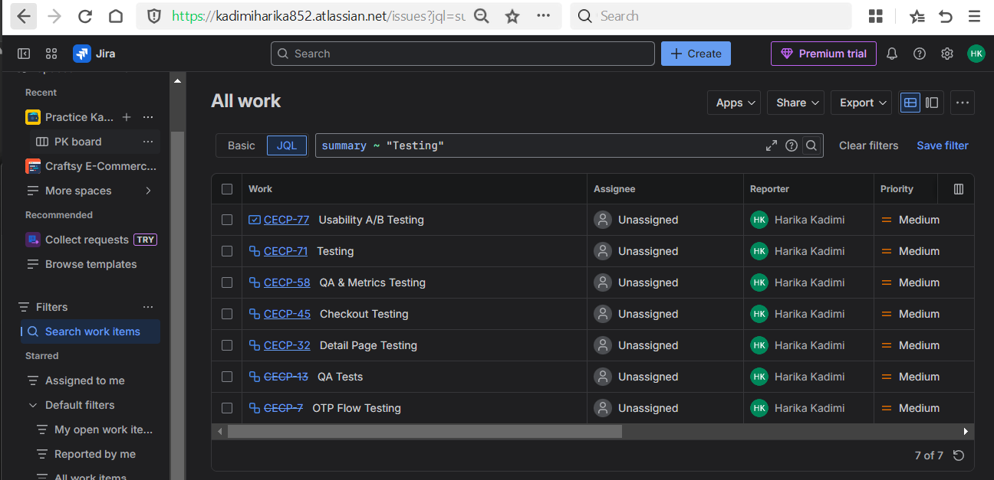

* Summary starts with “Keyword” -> summary ~ “keyword*”

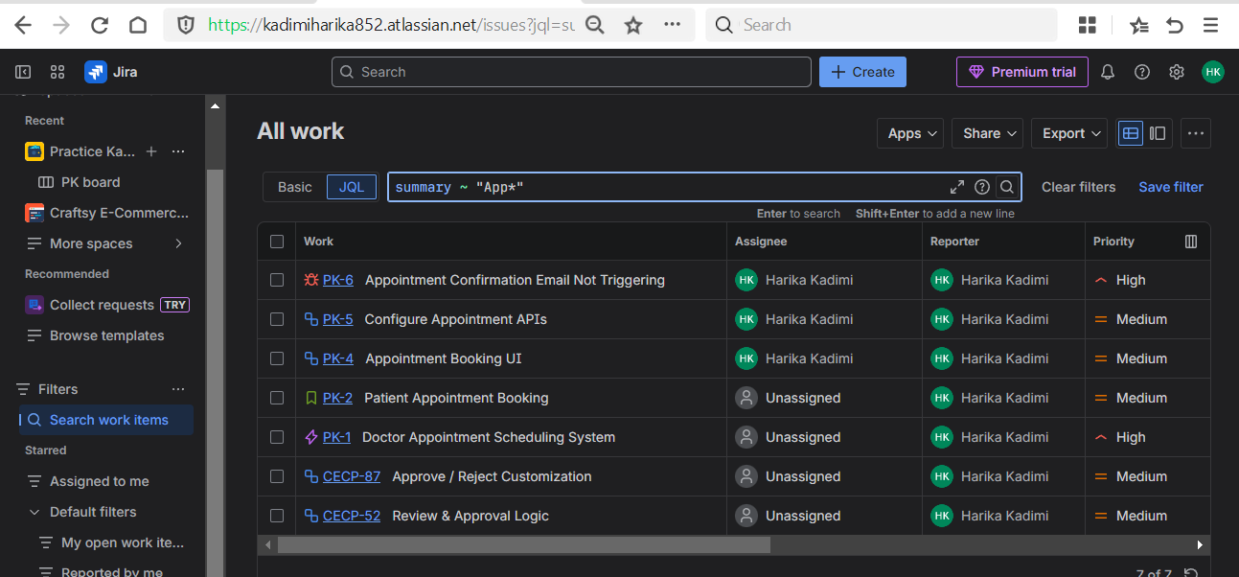

* Notes / Description mention keyword -> description ~ “keyword”

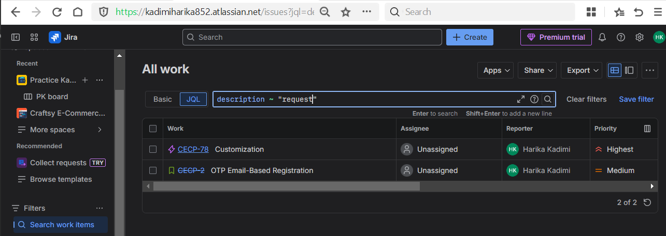

* All due before a data -> due < “Date”

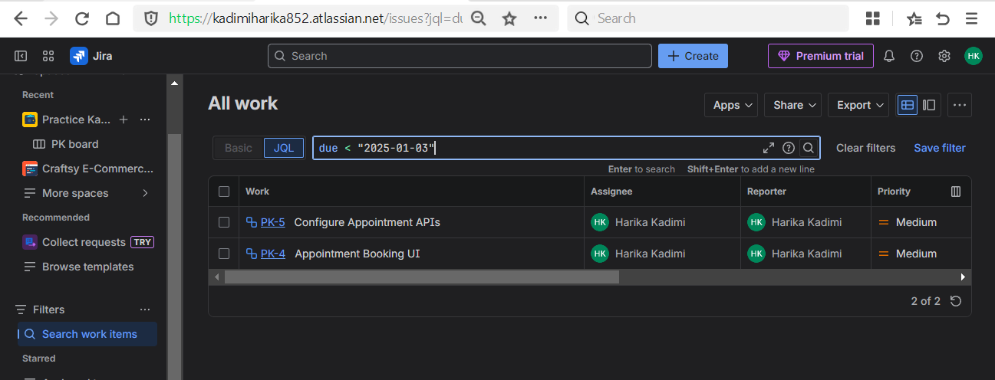

* Issues with no assignee -> assignee is EMPTY

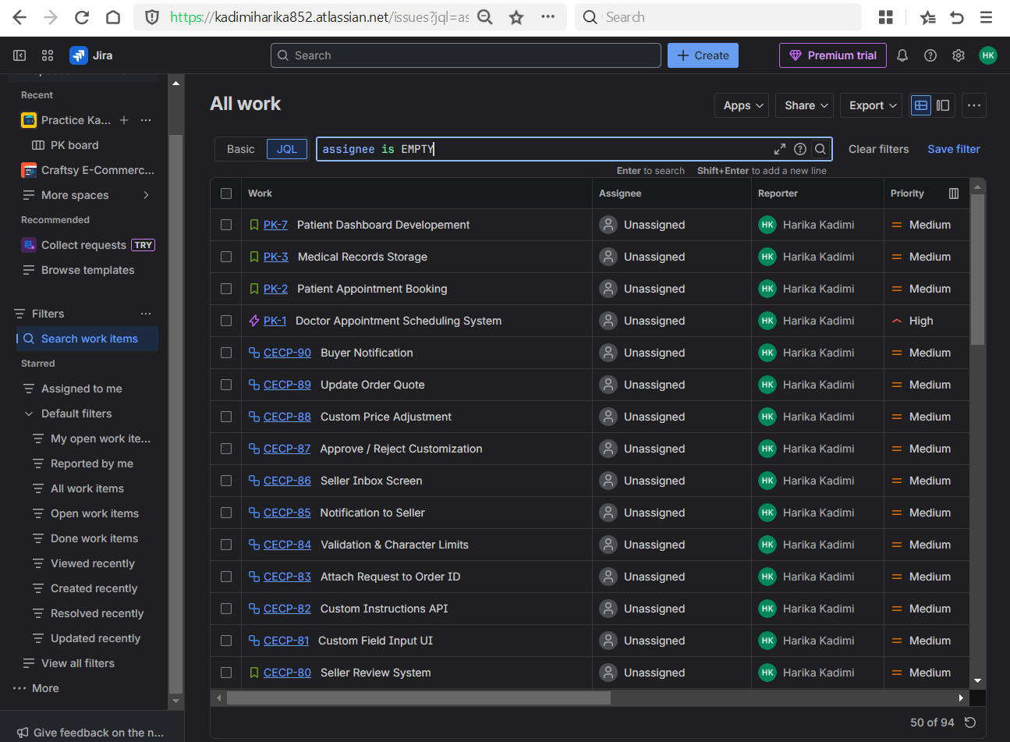

* Issue assigned to either Harika or Other -> assignee IN (Harika, Other)

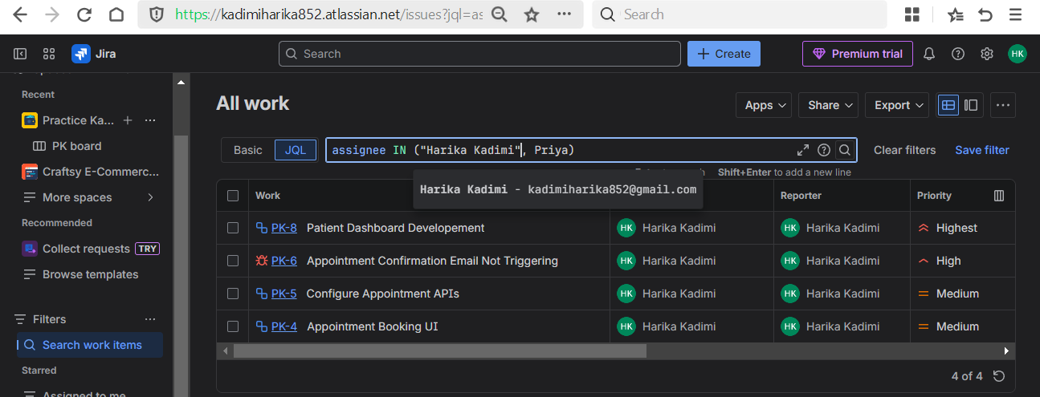

* Critical or High priority unfinished work -> (priority = Critical OR priority = High) AND status != Done

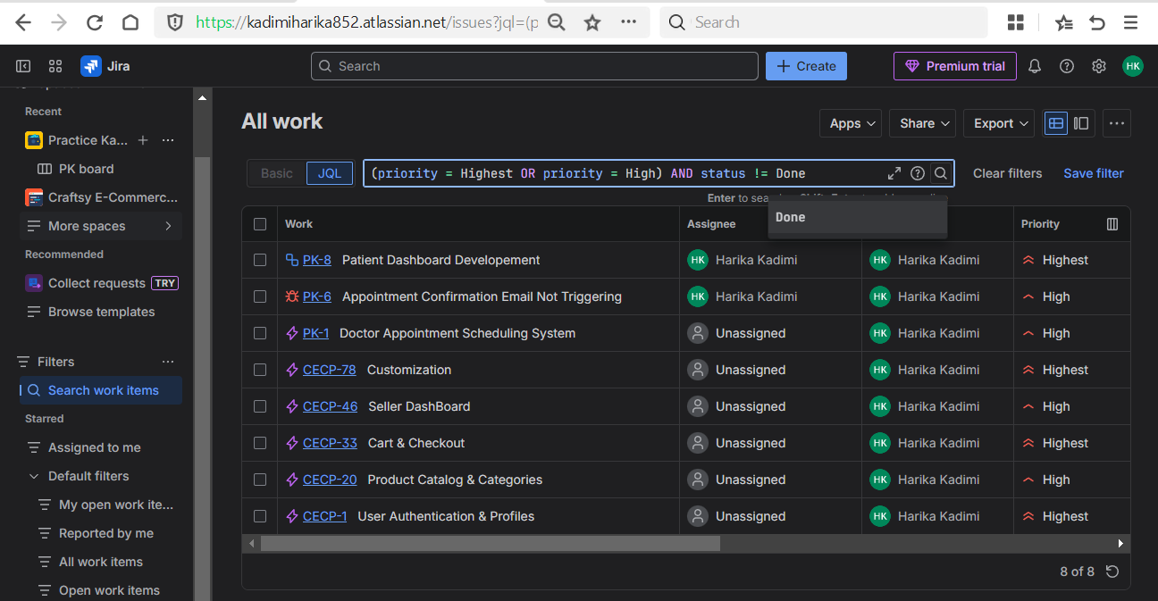

* Filter by multiple labels -> labels IN (urgent, devops, testing)

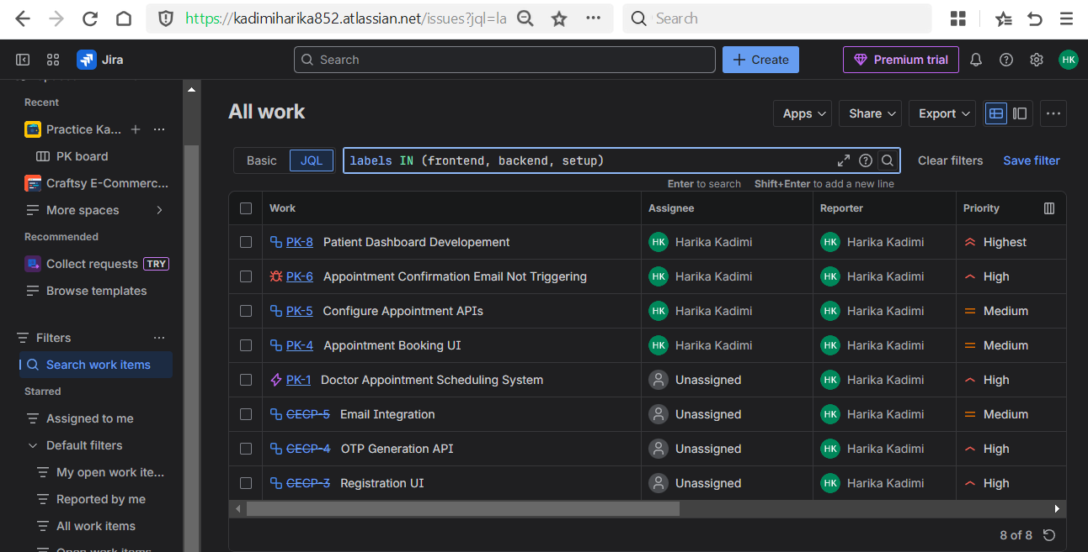

* Save filters

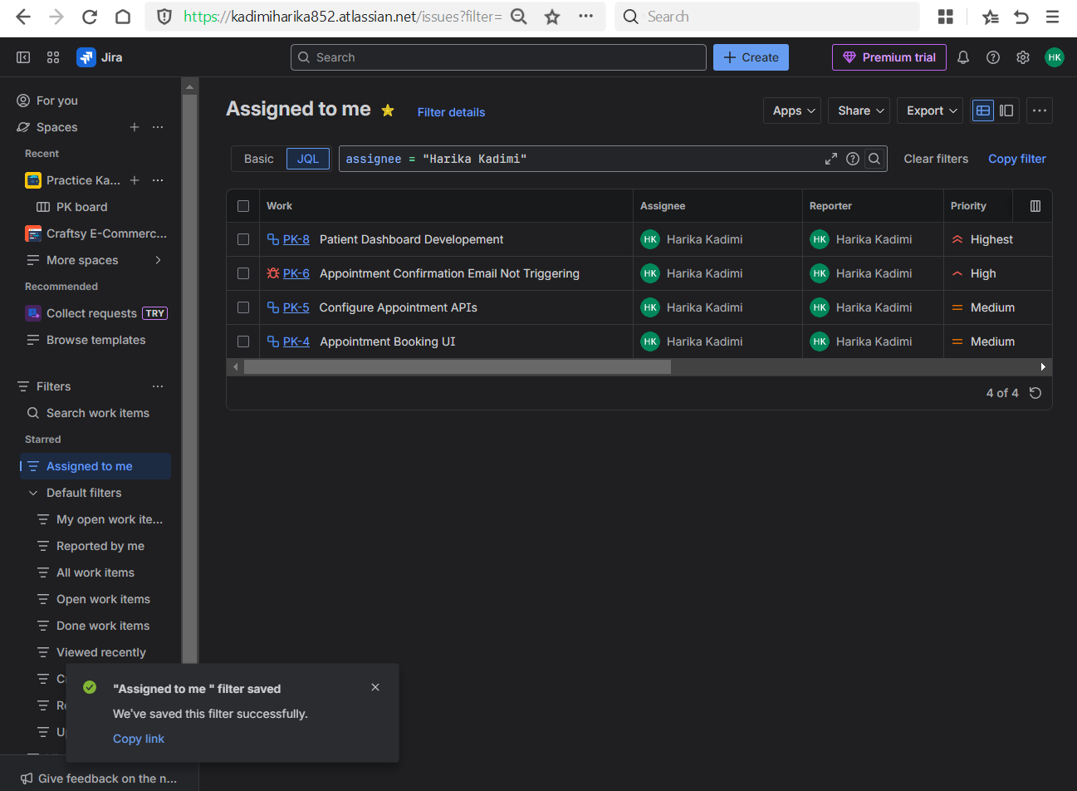

**Day 5 – Dashboards & Reports**

**Learn**

* Why managers use dashboards
* Agile reports importance

**Practical**

* Create a dashboard

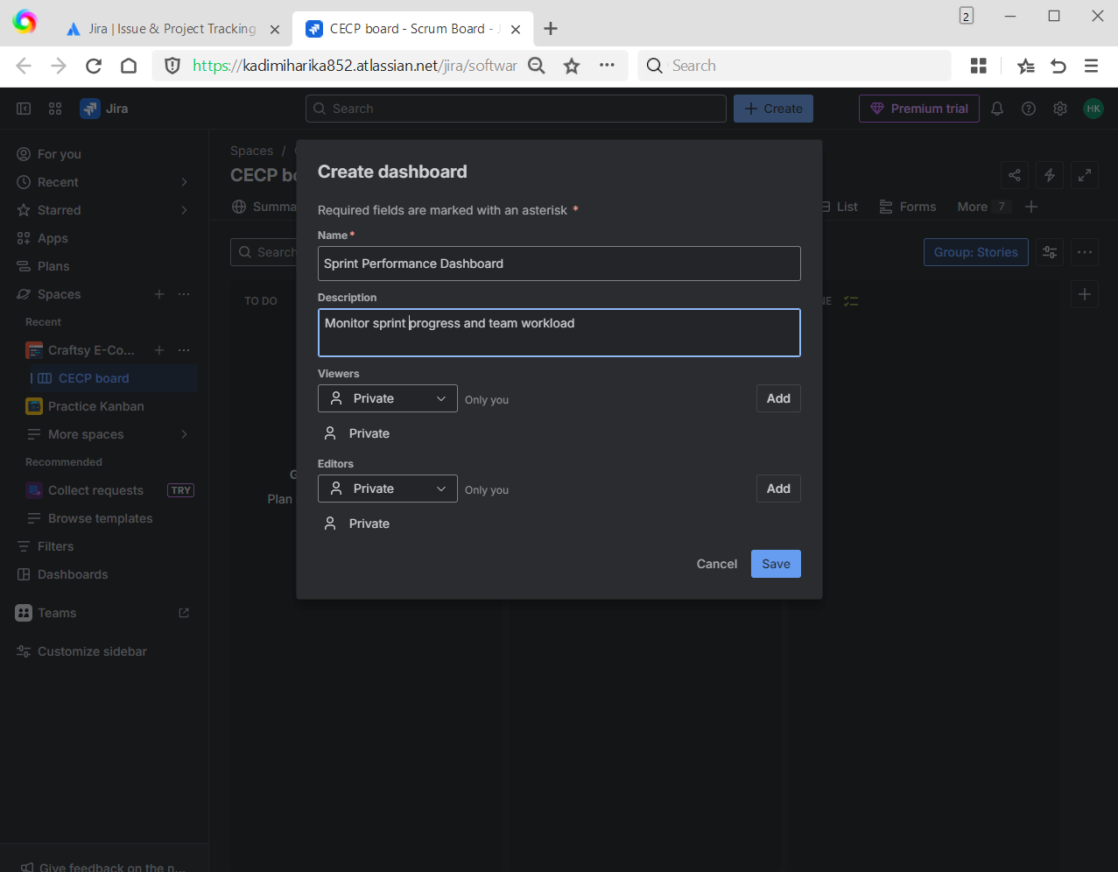

* Add gadgets:
  + Filter Results

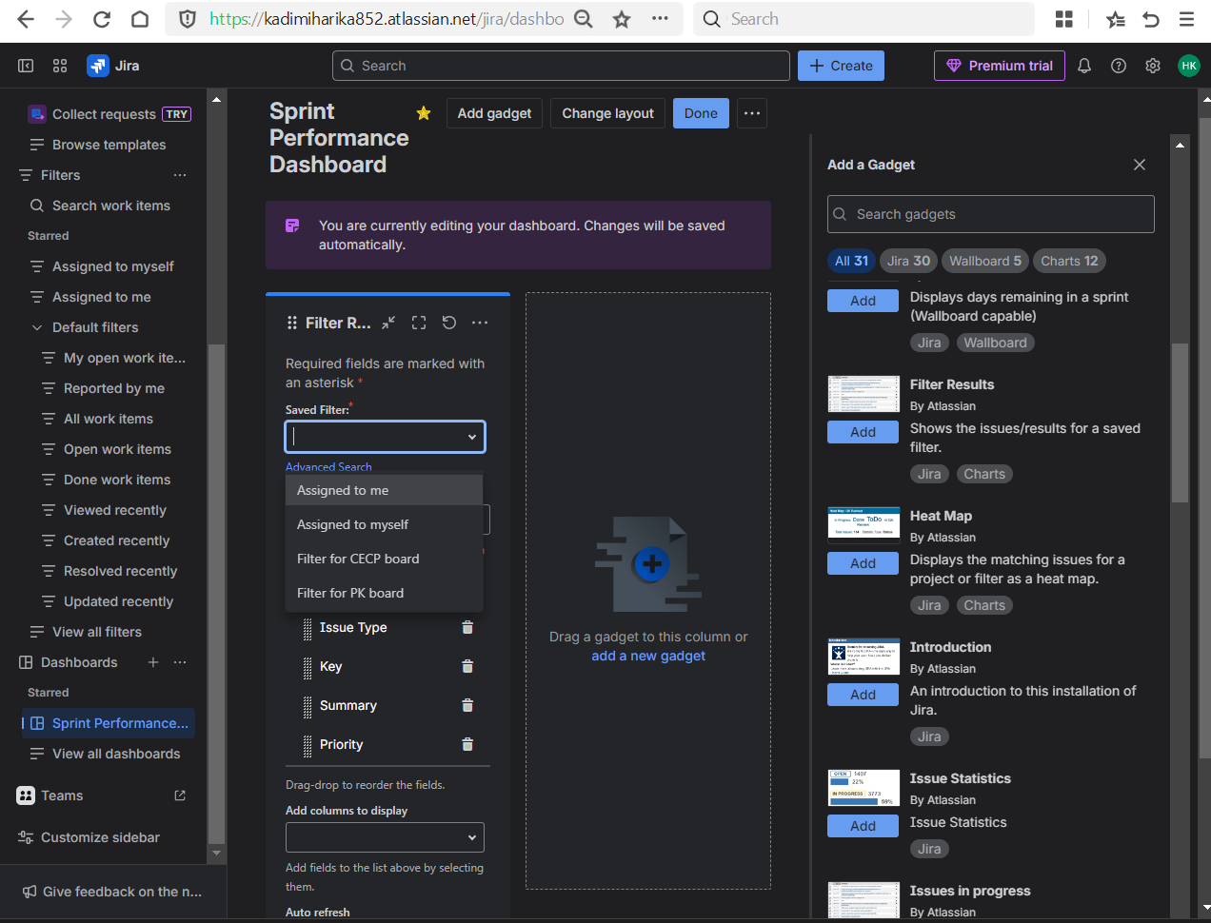

* After saving the filter the result as shown as below.

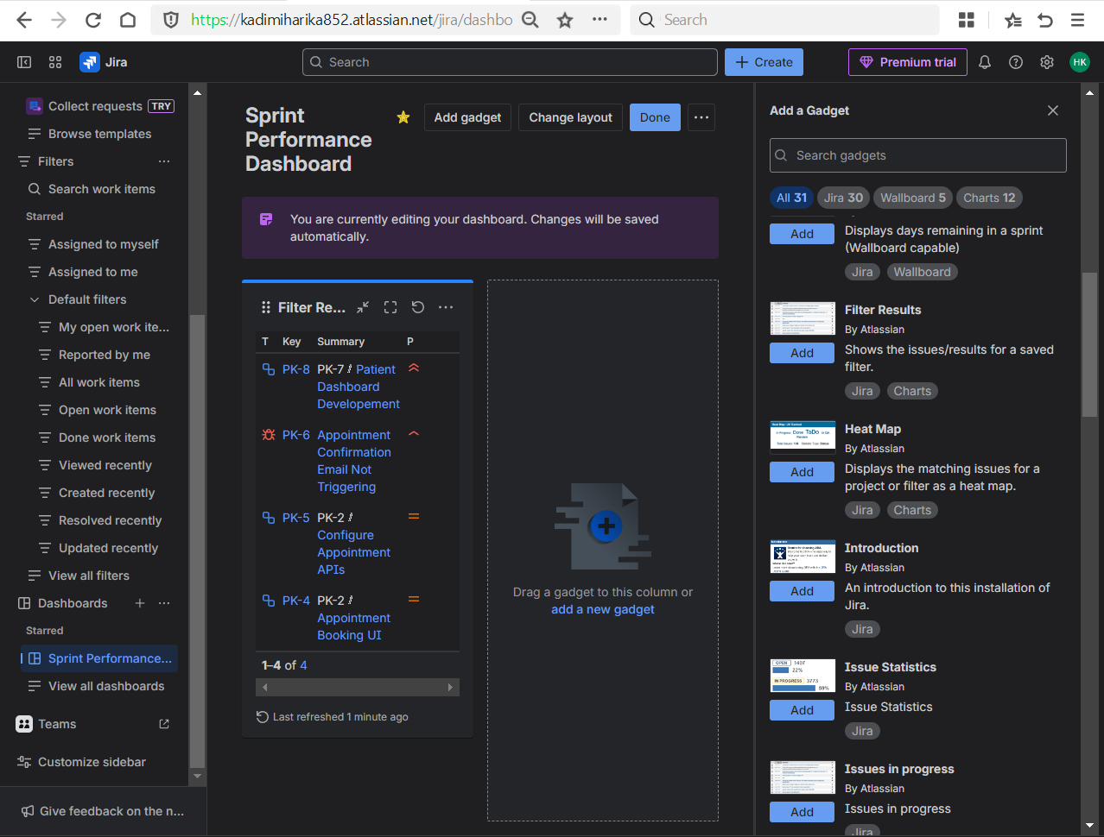

* + Sprint Burndown

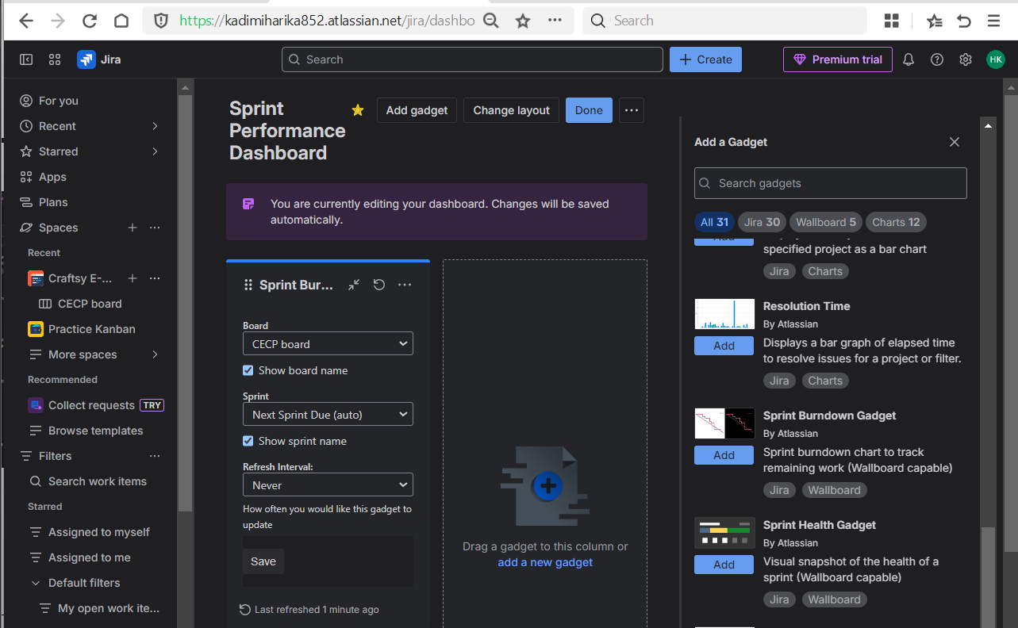

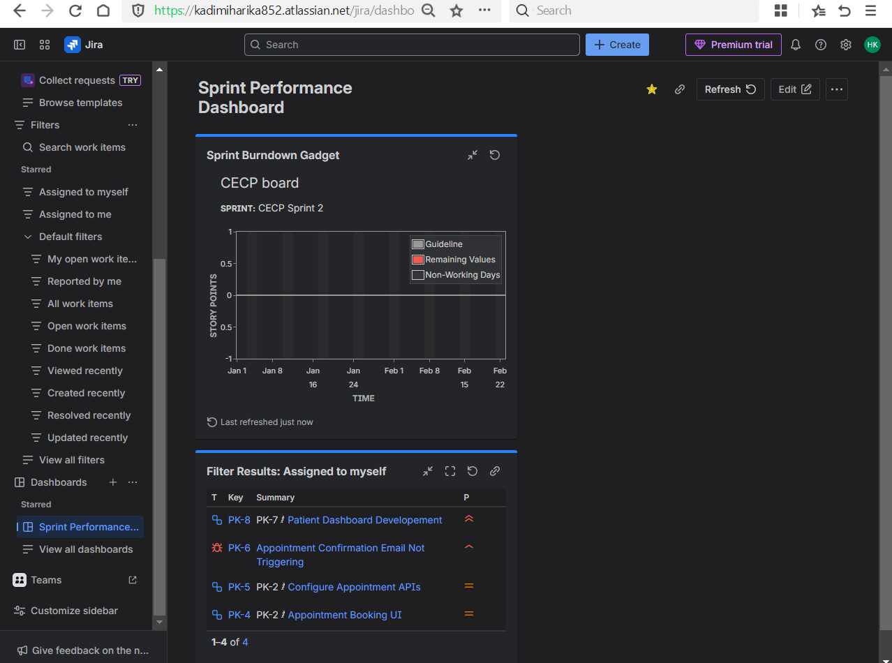

* + Pie Chart

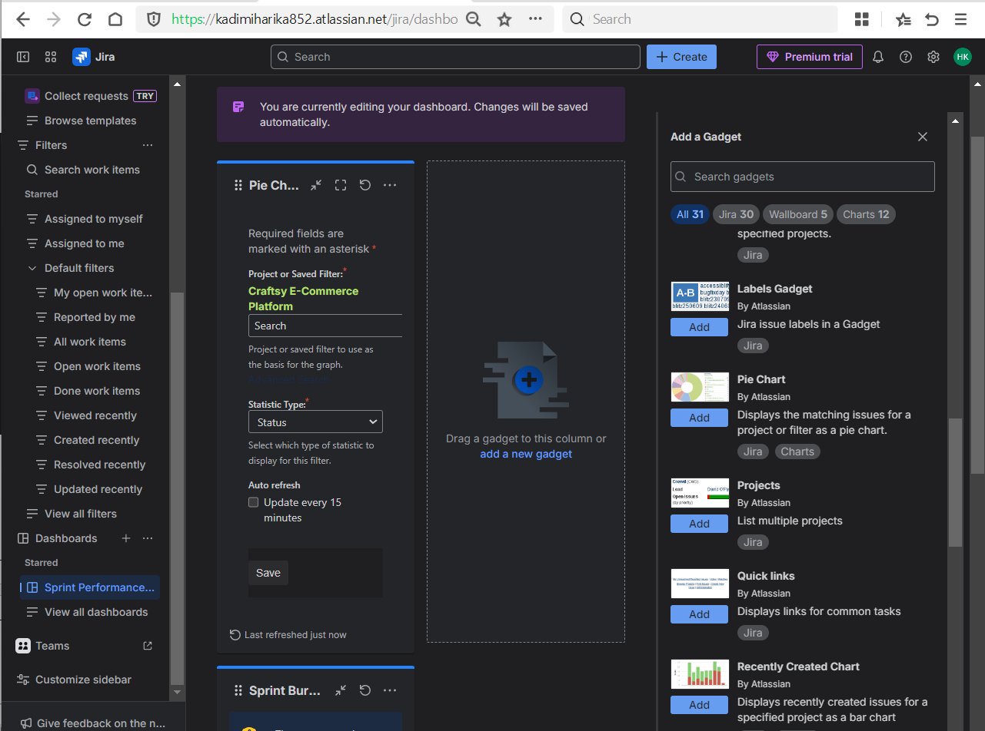

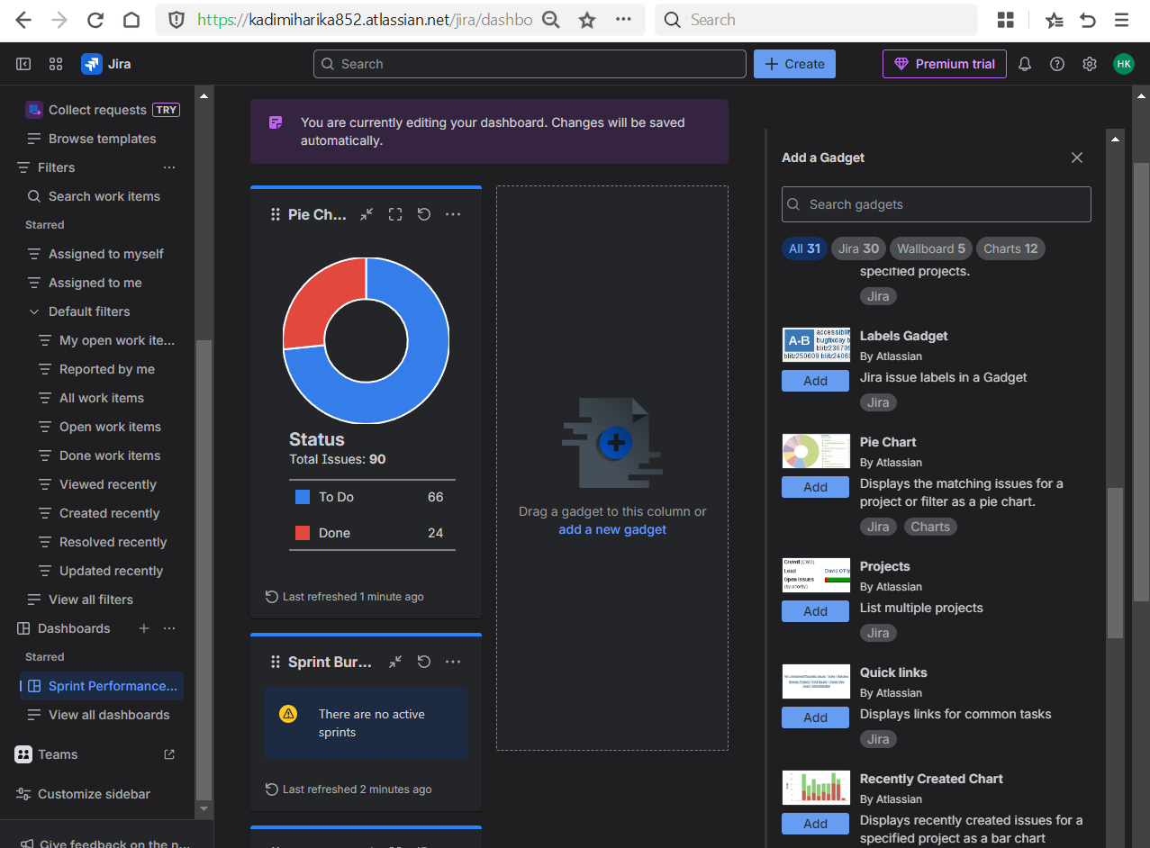

* View:
  + Velocity report

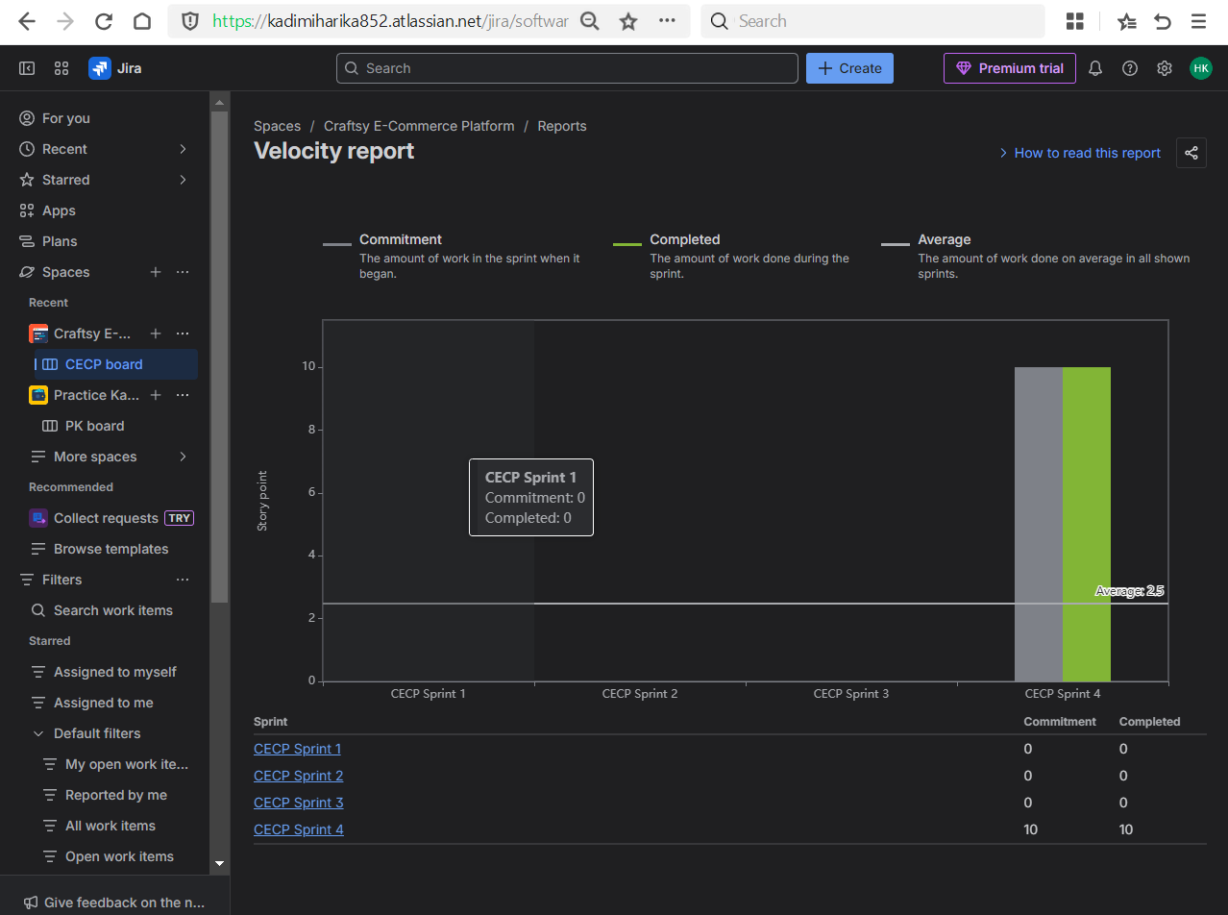

* + Burndown chart

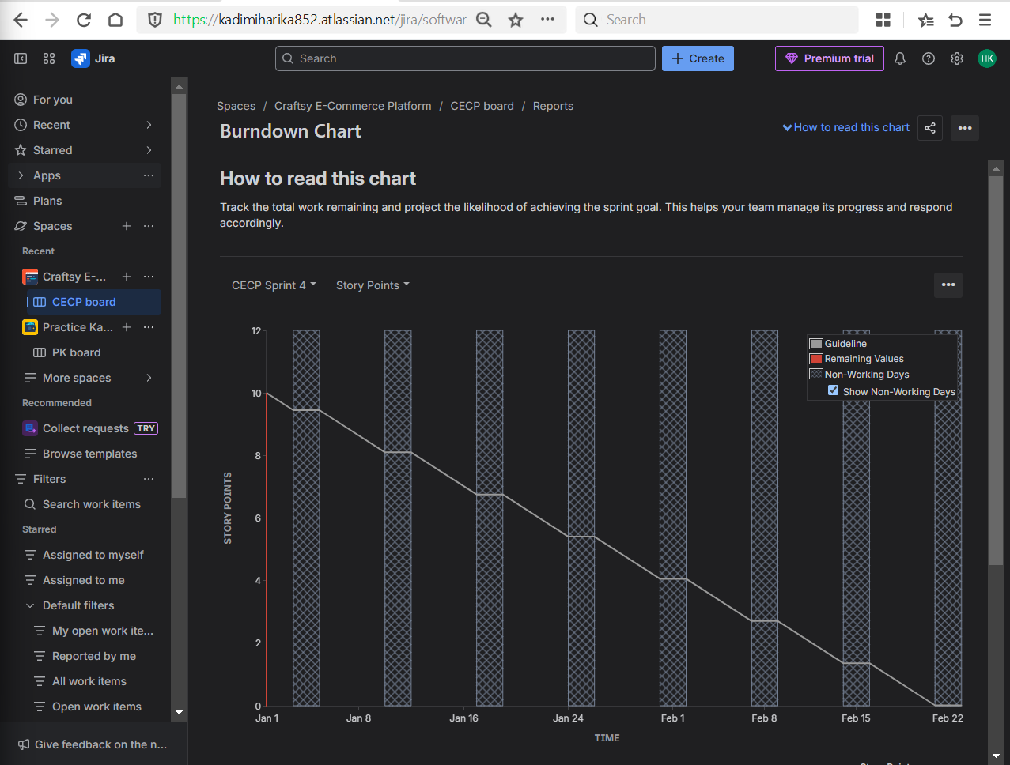

**Day 6 – Custom Fields + Real Project Simulation**

**Learn**

* Custom fields (what companies customize)
* Real bug tracking flow

**Practical**

* Add a custom field (Severity)
* Create bugs with:
  + Steps to reproduce
  + Expected vs actual result
* Simulate:
  + Bug → In Progress → Fixed → Done